CHAPTER 1
INTRODUCTION

1.1 Introduction to Internet of Things (IoT)
Internet of Things (IoT) is the networking of physical objects that contain electronics embedded within their architecture in order to communicate and sense interactions amongst each other or with respect to the external environment. In the upcoming years, IoT-based technology will offer advanced levels of services and practically change the way people lead their daily lives. Advancements in medicine, power, gene therapies, agriculture, smart cities, and smart homes are just a very few of the categorical examples where IoT is strongly established.
Over 9 billion ‘Things’ (physical objects) are currently connected to the Internet, as of now. In the near future, this number is expected to rise to a whopping 20 billion.
There are four main components used in IoT:
- Low-power embedded systems –
Less battery consumption, high performance are the inverse factors play a significant role during the design of electronic systems.

- Cloud computing –
Data collected through IoT devices is massive and this data has to be stored on a reliable storage server. This is where cloud computing comes into play. The data is processed and learned, giving more room for us to discover where things like electrical faults/errors are within the system.

- Availability of big data –
We know that IoT relies heavily on sensors, especially real-time. As these electronic devices spread throughout every field, their usage is going to trigger a massive flux of big data.

- Networking connection –
In order to communicate, internet connectivity is a must where each physical object is represented by an IP address. However, there are only a limited number of addresses available according to the IP naming. Due to the growing number of devices, this naming system will not be feasible anymore. Therefore, researchers are looking for another alternative naming system to represent each physical object.

There are two ways of building IoT:
- Form a separate internetwork including only physical objects.
- Make the Internet ever more expansive, but this requires hard-core technologies such as Rigorous cloud computing and rapid big data storage (expensive).

In the near future, IoT will become broader and more complex in terms of scope. It will change the world in terms of “anytime, anyplace, anything in connectivity.”

  - Introduction to Arduino
Arduino is an open-source electronics platform based on easy-to-use hardware and software. Arduino boards are able to read inputs - light on a sensor, a finger on a button, or a Twitter message - and turn it into an output - activating a motor, turning on an LED, publishing something online. You can tell your board what to do by sending a set of instructions to the microcontroller on the board. To do so you use the Arduino programming language (based on Wiring), and the Arduino Software (IDE), based on Processing.
Over the years, Arduino has been the brain of thousands of projects, from everyday objects to complex scientific instruments. A worldwide community of makers - students, hobbyists, artists, programmers, and professionals - has gathered around this open-source platform, their contributions have added up to an incredible amount of accessible knowledge that can be of great help to novices and experts alike.
Arduino was born at the Ivrea Interaction Design Institute as an easy tool for fast prototyping, aimed at students without a background in electronics and programming. As soon as it reached a wider community, the Arduino board started changing to adapt to new needs and challenges, differentiating its offer from simple 8-bit boards to products for IoT applications, wearable, 3D printing, and embedded environments. All Arduino boards are completely open-source, empowering users to build them independently and eventually adapt them to their particular needs. The software, too, is open-source, and it is growing through the contributions of users worldwide.
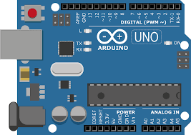

Fig 1.2 Arduino UNO

1.2.1 Problem Statement
The main aim of this project is develop a secure door locking system based on fingerprint scanning. In this project, microcontroller accompanied with an interface circuit has been used for opening and closing door lock based on fingerprint which is stored in fingerprint sensor database so that only authorized person will access the secure door lock.

1.2.2 Scope
Human fingerprints are extremely detailed and nearly unique. What is more, they are also very difficult to fake or alter and can endure over an individual’s lifespan. This makes them very suitable as long-term markers of human identity. When the technology that can recognize and differentiate between fingerprints is deployed in securing access to a doorway, you get a “Fingerprint Door Lock System”.

CHAPTER 2
LITERATURE SURVEY

2.1 Door Locking and Security System
Today people are facing more problems about security in all over world, nowadays security is the most essential issue everywhere in the world; so security of everything gains higher and higher importance in recent years. Here, we are trying to reproduce the comprehensive literature study related to the various door locks and security systems that are necessary in the fields such as home, industries and vehicle security where possibilities of incursion are increasing day by day. In past days, the research is gone on various door lock security systems like traditional security systems, which provide indications using alarm. Due to the advancement in recent techniques, some door lock security systems are based on microcontroller, GSM, GPS, many sensors, software like MATLAB, PROTEUS, and Biometrics like fingerprint, face recognition, Iris scanner, RFID, Smart Card etc. Each system has their own advantages and disadvantages. In most of systems, SMS technique is used for communication so the system will become cost effective, more reliable and it will take less time to deliver message. As security becomes major problem nowadays, the security monitoring systems today needs to make use of the latest technology. In addition, the enhanced security systems are available based on android platform, wireless techniques and embedded systems. A lot of modification takes places in various Door lock security from the last few years, in next coming years many changes will takes place.

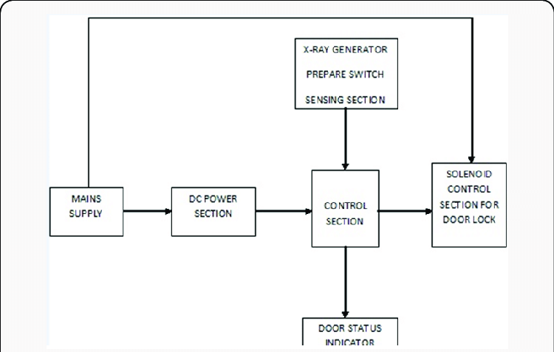
Fig 2.1 Block Diagram for Door Locking System

2.2 Fingerprint Sensor
A fingerprint sensor is an electronic device used to capture a digital image of the fingerprint pattern. The captured image is called a live scan. This live scan is digitally processed to create a biometric template (a collection of extracted features) which is stored and used for matching. Many technologies have been used including optical, capacitive, RF, thermal, piezo resistive, ultrasonic, piezoelectric.
The overview of some of the more commonly used fingerprint sensor technologies are:
  - Optical
Optical fingerprint imaging involves capturing a digital image of the print using visible light. This type of sensor is, in essence, a specialized type of digital camera. The top layer of the sensor, where the finger is placed, is known as the touch surface. Beneath this layer is a light-emitting phosphor layer, which illuminates the surface of the finger. The light reflected from the finger passes through the phosphor layer to an array of solid-state pixels (a charge-coupled device) which captures a visual image of the fingerprint. A scratched or dirty touch surface can cause a bad image of the fingerprint. A disadvantage of this type of sensor is the fact that the imaging capabilities are affected by the quality of skin on the finger. For instance, a dirty or marked finger is difficult to image properly. In addition, it is possible for an individual to erode the outer layer of skin on the fingertips to the point where the fingerprint is no longer visible. It can also be easily fooled by an image of a fingerprint if not coupled with a "live finger" detector. However, unlike capacitive sensors, this sensor technology is not susceptible to electrostatic discharge damage. Fingerprints can be read from a distance.

  - Ultrasonic
Ultrasonic sensors make use of the principles of medical ultrasonography in order to create visual images of the fingerprint. Unlike optical imaging, ultrasonic sensors use very high frequency sound waves to penetrate the epidermal layer of skin. The sound waves are generated using piezoelectric transducers and reflected energy is also measured using piezoelectric materials. Since the dermal skin layer exhibits the same characteristic pattern of the fingerprint, the reflected wave measurements can be used to form an image of the fingerprint. This eliminates the need for clean, undamaged epidermal skin and a clean sensing surface. LeEco became the first company to introduce this in Smartphone. The sensor was designed and made by Qualcomm

  - Capacitance
Capacitance sensors use principles associated with capacitance in order to form fingerprint images. In this method of imaging, the sensor array pixels each act as one plate of a parallel-plate capacitor, the dermal layer (which is electrically conductive) acts as the other plate, and the non-conductive epidermal layer acts as a dielectric. Apple's Touch ID uses a capacitance fingerprint sensor.

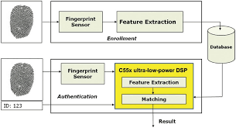
Fig 2.2 Block Diagram for Fingerprint Sensor

CHAPTER 3
REQUIREMENT SPECIFICATION
3.1 Hardware Requirements
The hardware requirements are very minimal and the software can run on most of the machines.

- Processor - Intel i5 Processor or above.
- Processor Speed – 2.5GHz or above
- RAM – 8GB or above
- Storage Space – 1TB or above

3.2 Software Requirements

- Windows 10 Operating System
- Arduino IDE

3.3 Components Required

- Adafruit Fingerprint Sensor R307
- 12V Solenoid Lock
- Arduino Uno
- Relay Module
- 12V Power Adapter

CHAPTER 4
METHODOLOGY

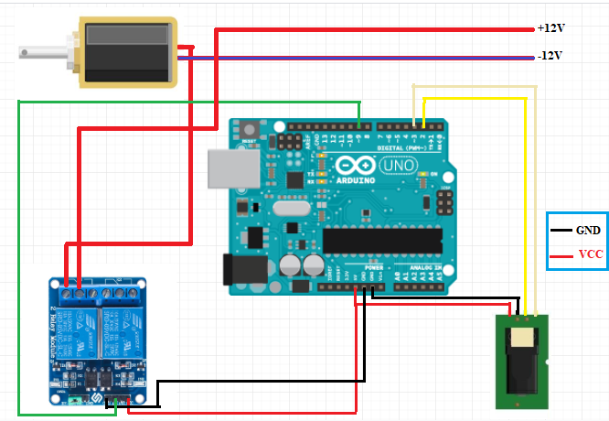
Fig 4.1 Circuit Diagram of Fingerprint Door Locking System

- The Connections are made as per above Circuit Diagram. We are giving input from 12V Power Adapter.
- It gives power for both Arduino and Solenoid Lock. We have used R307 Fingerprint Sensor.
- We have used two Channel Relay module to control Lock/Unlock Solenoid Lock. When Solenoid Lock gets the power supply, it gets unlocked and when there is no power supply, it is locked.
- Power is given based the correct image of fingerprint on the Fingerprint Sensor.

CHAPTER 5
RESULTS
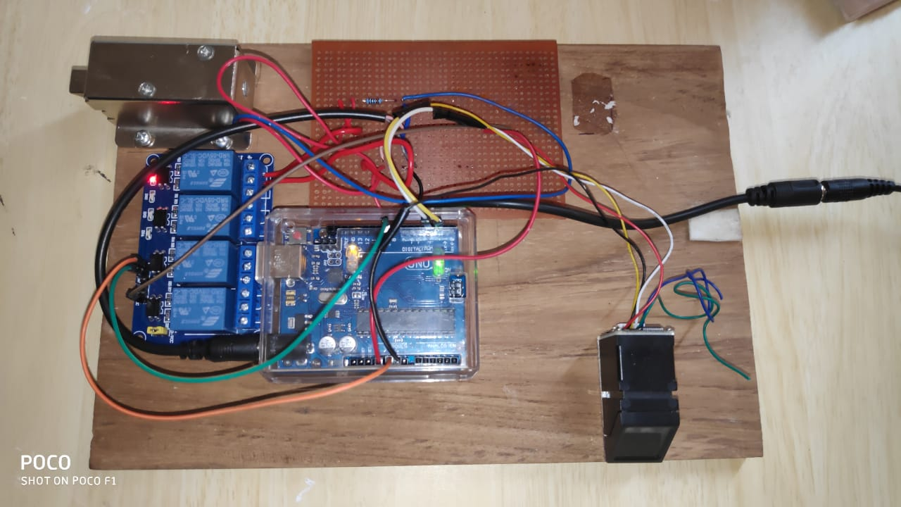
5.1 SCREENSHOTS
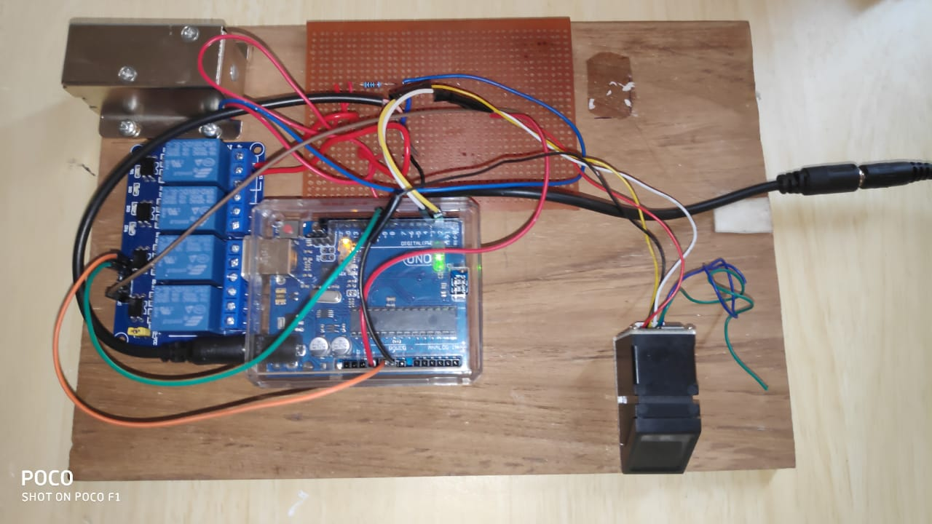
Fig 5.1.1 When it is Locked
Fig 5.1.2 When it is Unlocked

CHAPTER 6
CONCLUSION & FUTURE ENHANCEMENT

6.1 Conclusion
The main advantages of using this system are:
1. Easy to use and requires no special training or equipment.
2. Fingerprint is unique for every person it cannot be imitated or fabricated. It is not same in the case of twins also.
3. High accuracy in terms of security.
4. No manual errors.
5. No false intrusions.
A systematic approach in designing the microcontroller based system for securing the transactions of the user and providing the security for the locker system. The result obtained in providing the security is quite reliable in all the three modes. The system has successfully overcome some of the aspects existing with the present technologies, by the use of fingerprint Biometric as the authentication Technology.

6.2 Future Enhancements
In future, alarm will be introduced. When intruder tries to break the door, the vibration is sensed by sensor, which makes an alarm. This will inform the neighbors about intruders and this will help to take further action to prevent intruder from entering. In addition, we will be adding LCD Display indicating that correct fingerprint has been detected.

REFERENCES
Referred Books

[1]. David Hanes, Gonzalo Salgueiro, Patrick Grossetete, Robert Barton, Jerome

Henry, "IoT Fundamentals: Networking Technologies, Protocols, and Use

Cases for the Internet of Things”, First Edition, Pearson Education (Cisco Press

Indian Reprint). (ISBN: 978-9386873743)

Websites Referred

- https://youtu.be/ZzOMemOQAF0
- https://youtu.be/Bv_x89Sbads.

